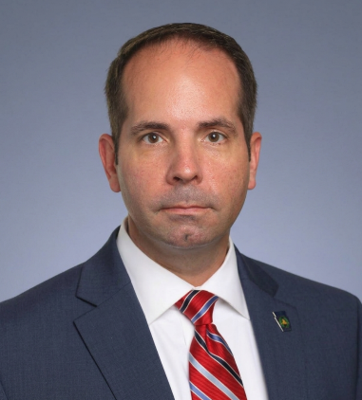
Brian Kohlhepp is a Deputy Chief of Police from the Pittsburgh area where he oversees departmental operations while continuing to supervise the Detective Division and the Forensic Investigation Unit. Over the course of his career, he has spent the majority of his time assigned to criminal investigations, serving as both a Detective and Detective Sergeant specializing in homicide, suspicious deaths, sexual assault, and child abuse investigations.

Deputy Chief Kohlhepp has conducted and supervised numerous forensic examinations and major crime scene investigations ranging from homicide and sexual assault to complex property crimes. He has testified as an expert in forensic crime scene reconstruction and has extensive experience in death investigations, violent crime investigations, and forensic evidence analysis and Bloodstain Pattern Analysis. In addition to his investigative responsibilities, he serves as a department Public Information Officer responsible for coordinating media communications during major incidents and investigations. He is also a member of the FBI’s Joint Terrorism Task Force.

During his investigative career, Deputy Chief Kohlhepp served as the lead investigator in a multi-jurisdictional investigation of a violent serial rapist that gained national media attention and resulted in an arrest and successful prosecution. He also assisted in the investigation of a homicide and $2.3 million armored truck robbery that led to a nationwide manhunt and eventual arrest after the case was featured on America's Most Wanted.

Deputy Chief Kohlhepp is a graduate of the FBI National Academy and is a certified polygraph examiner. He holds a bachelor’s degree in criminal justice from Waynesburg University and a master’s degree from Pennsylvania Western University–California, where he graduated summa cum laude.

In addition to his law enforcement career, Deputy Chief Kohlhepp is an FBI and MPOETC certified instructor and serves as an Assistant Professor of Legal Studies at Pennsylvania Western University. He also teaches undergraduate and graduate courses at John Jay College of Criminal Justice, Duquesne University, and Waynesburg University.
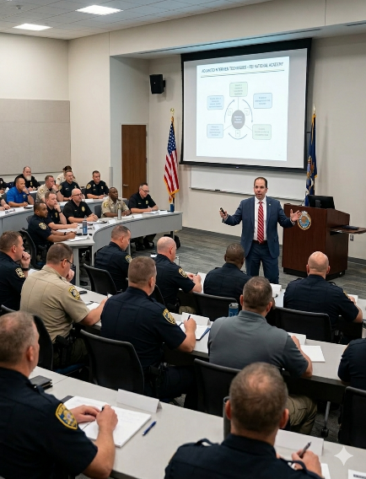
Deputy Chief Kohlhepp regularly provides investigative and forensic training to law enforcement officers, prosecutors, and forensic professionals and has presented at major national conferences, and numerous regional events for law enforcement, legal, healthcare, and forensic professionals.

He is a Past President of the Pennsylvania Division of the International Association for Identification and sits on the boards of the Mid-Atlantic Cold Case Homicide Investigators Association (MACCHIA), the Allegheny County Hospital Forensic Advisory Council, Pittsburgh Action Against Rape (PAAR), and has been awarded the title of Colonel of the Commonwealth of Kentucky by the Governor. He has received numerous awards and commendations from law enforcement agencies, prosecutors’ offices, and victim advocacy organizations for his investigative work and professional contributions to the field.

