Faculty/Staff Student Engagement Program
(FSSEP) Procedures
Updated: August 22, 2025
The Division of Enrollment Management & Student Affairs is excited to present the
Faculty/Staff Student Engagement Program sponsored by the Student Activities Association. The Division of Enrollment Management & Student Affairs is dedicated to supporting the mission of the College and academic success of our students. Research indicates that engagement with faculty, outside the classroom, is a strong and positive contributor to retention. These interactions, when intentional and purposeful, help to strengthen students’ relationship to the College. With this spirit, the Faculty/Staff Student Engagement Program is comprised of the following initiative: Faculty/Staff Student Engagement Fund.

Table of Contents
Purpose ........................................................................................................................................ 2 Definitions ................................................................................................................................... 2 Eligibility ..................................................................................................................................... 2 Funding Limits ............................................................................................................................ 2
How to Apply ............................................................................................................................... 2
Guest Speakers/Performers ........................................................................................................ 2
Important Identification Requirements for Guest Speakers and Performers ........................ 2
Catering ....................................................................................................................................... 3
Reimbursement ........................................................................................................................... 3
Reimbursement Checklist ....................................................................................................... 3 Contacts and Forms .................................................................................................................... 3
Compliance .................................................................................................................................. 4
Funding Guide (Do’s & Don’ts) ................................................................................................... 5
Funding Guide .......................... ................................................................................................... 6
Event Description Form ................................................................................................................7
Event Attendance Form ................................................................................................................8

Faculty/Staff Student Engagement Program (FSSEP) — Procedures

Purpose
FSSEP supports faculty and staff who organize student engagement activities. This policy explains eligibility, funding, and required steps.
Definitions
Event: A student engagement activity organized or led by a faculty or staff member.
Eligibility
All John Jay faculty (full-time or adjunct) and staff (full-time or part-time) may apply.

Funding Limits
- Up to $400 per faculty or staff member, per event.
- No more than two faculty or staff members may receive funding for the same event.
- A faculty or staff member may receive funding more than once per semester, subject to available funds.

How to Apply
- Submit the FSSEP application by the posted deadline.
- If your application includes a guest speaker/performer, submit it at least 3 weeks before the event date.
- You will receive a decision within 3–5 business days after submission.

Funding Guide (Do’s & Don’ts)
All requests and purchases must comply with the FSSEP Funding Guide (Do’s & Don’ts). Refer to the guide for allowable and prohibited uses, pass‑through reimbursement rules, and documentation standards. If a request conflicts with the guide, it will be denied.

Guest Speakers/Performers
- A contract is required before the service date. The Student Activities Association (SAA) Business Office issues the contract.
- To start the contract, email fse@jjay.cuny.edu with the guest’s legal name, active email, and phone number.

Important Identification Requirements for Guest Speakers and Performers
To be eligible to serve as a guest speaker or performer, individuals must have:
- A valid Social Security card, and
- One valid form of photo identification, such as: State-issued ID, U.S. Passport, Permanent Resident Card, or Employment Authorization Document (Form I-766).
- No payment will be issued if required contract paperwork is not completed before the service date.
- After the event, the faculty or staff member must email fse@jjay.cuny.edu to confirm whether services were rendered.
- If the faculty or staff member seeks related reimbursement (e.g., travel or meals), they must follow the FSSEP Reimbursement Checklist.
- CUNY employees cannot be paid as independent contractors. If a proposed guest is a CUNY employee, contact the SAA Business Office for guidance on permissible payment processes.

Catering
- Faculty or staff members may request catered food for student events.
- Submit the Catering Request Form to fse@jjay.cuny.edu at least 1 week before the event for approval. Forms and menus are available at www.jjay.cuny.edu/fsse.
- To cancel catering, email fse@jjay.cuny.edu at least 3 days before the event. Late cancellations may result in out-of-pocket costs to the faculty or staff member.

Reimbursement
No cash advances. FSSEP does not advance funds for activities. Submit reimbursement after the activity is complete. Include all items listed on the FSSEP Reimbursement Checklist.
Reimbursement Checklist
Faculty and staff cannot be advanced funds for approved activities and must submit reimbursement paperwork upon completion of activity. The reimbursement checklist serves as
an overview of documentation required for submission. Faculty or staff is encouraged to email their reimbursement paperwork to fse@jjay.cuny.edu.

Required documents
- Event Description Form (download at www.jjay.cuny.edu/fsse).
- Event Attendance Form (download at www.jjay.cuny.edu/fsse). Not required if the faculty or staff member was approved for a guest speaker/performer.
- Itemized receipts for all purchases (cash/credit/debit/check) showing business name, date, items, and total.
- Flyer or brochure for the event/activity.
If you paid by credit, debit, or check
- Include a copy of the official bank or card statement for the account used. You may black out unrelated transactions, but your name and address must be visible.
- Only official statements are accepted (no screenshots or edited images).
Helpful tips to avoid delays
- Make sure totals on receipts match the amounts on your statement.
- If multiple events were held, separate receipts and forms by event.
- Keep copies of everything you submit.

Contacts and Forms
- Email: fse@jjay.cuny.edu
- Forms and resources: www.jjay.cuny.edu/fsse (application, catering request, reimbursement checklist)
- Contracts: Initiated through the SAA Business Office (email fse@jjay.cuny.edu to begin)

Compliance
- Late or incomplete applications are not accepted.
- Requests that miss the 3-week speaker deadline or 1-week catering deadline may be denied.
- Missing the 3-day catering cancellation window may create personal liability for costs for the faculty or staff member.


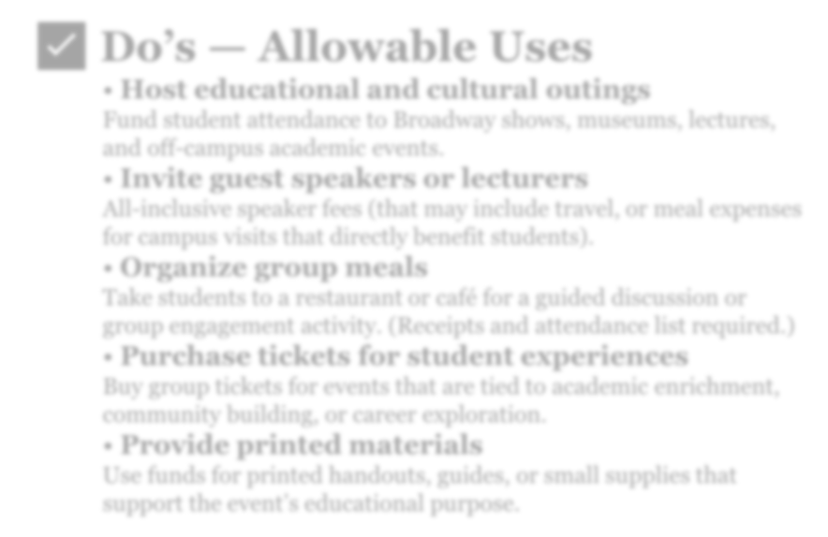
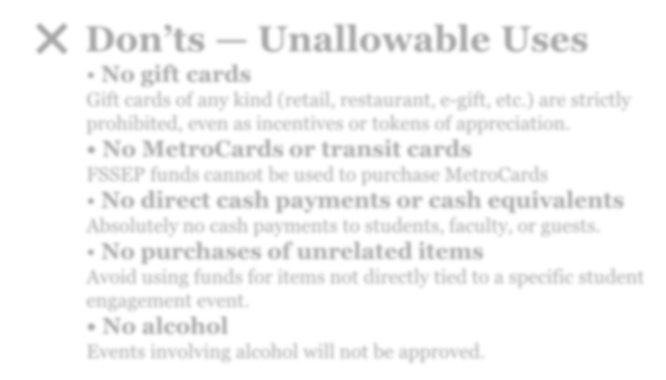
Faculty Staff Student Engagement Program (FSSEP) Funding Do’s & Don’ts

✅ Do’s — Allowable Uses

• Host educational and cultural outings
Fund student attendance to Broadway shows, museums, lectures, and off-campus academic events.

• Invite guest speakers or lecturers
All-inclusive speaker fees (that may include travel, or meal expenses for campus visits that directly benefit students).

• Organize group meals
Take students to a restaurant or café for a guided discussion or group engagement activity. (Receipts and attendance list required.)

• Purchase tickets for student experiences
Buy group tickets for events that are tied to academic enrichment, community building, or career exploration.

• Provide printed materials

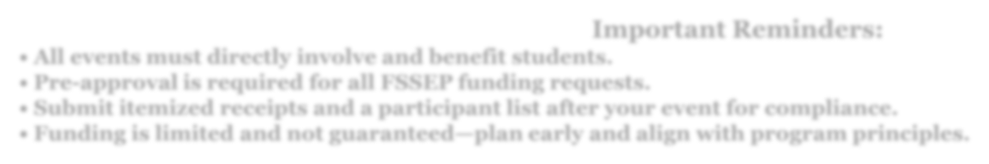
Use funds for printed handouts, guides, or small supplies that support the event’s educational purpose.
Important Reminders:
•All events must directly involve and benefit students.
•Pre-approval is required for all FSSEP funding requests.
•Submit itemized receipts and a participant list after your event for compliance.
•Funding is limited and not guaranteed—plan early and align with program principles.
pg
.
5

❌ Don’ts — Unallowable Uses

• No gift cards
Gift cards of any kind (retail, restaurant, e-gift, etc.) are strictly prohibited, even as incentives or tokens of appreciation.

• No MetroCards or transit cards
FSSEP funds cannot be used to purchase MetroCards • No direct cash payments or cash equivalents
Absolutely no cash payments to students, faculty, or guests.

• No purchases of unrelated items
Avoid using funds for items not directly tied to a specific student engagement event.
• No alcohol
Events involving alcohol will not be approved

Faculty/Staff Student Engagement Program (FSSEP)
Funding Guide
Updated: August 22, 2025

Allowed Uses (Do’s)
- Buy tickets for approved educational/cultural events for students and submit itemized receipts with an attendee list.
- Pay a restaurant (or other business) directly for a student group meal; submit an itemized receipt and attendee list.
- If a business only accepts an app (e.g., Cash App Pay/PayPal at checkout), ensure the receipt shows the business name, date, items, and total PRIOR to payment—then submit for reimbursement.
- Coordinate any speaker or service through the SAA Business office so the office handles contracting and payment.

Prohibited Uses (DO NOT)
- Paying individuals directly for services or honoraria (must be contracted and paid by the office).
- Reimbursing or paying other staff members for what they purchased (e.g., Staff A pays Staff B back for food).
- Peer-to-peer app transfers to people for goods and services (Zelle, Venmo, Cash App, PayPal to an individual).
- Cash equivalents (gift cards, e-gift/prepaid cards, store credit, MetroCards, transit cards). Do not give students cash to make their purchases.

Pass-Through Reimbursements — What This Means
The person seeking reimbursement must be the person who paid the business directly for the eligible purchase. You may not pay or reimburse another person (staff, faculty, or student) and then ask FSSEP to reimburse you. If another person needs to be reimbursed, they must submit their own eligible, documented purchase directly (or the office should pay the vendor).

How to Pay / Request Reimbursement
- Services & Contracts (speakers, performers, facilitators):
Contact the SAA Business Office to initiate CUNYBuy vendor registration (vendor management unit-facilitated)/contracting. The SAA Business Office pays the vendor directly. Do not pay individuals directly for services. Note: CUNY employees can’t be paid as independent contractors.
- Business Purchases (including app-based business checkouts): Submit itemized receipts showing business name, date, items, total, and proof of payment.
- Documentation: Include a brief event description and attendee list for food/meals and ticketed events.

Quick Check
- Is the payee a person? → Stop and contact the SAA Business office (services must be contracted).
- Is a personal payment app involved? → Allowed only if it’s a business checkout with an itemized business receipt; not allowed for paying a person.
- Is this a direct purchase from a business with an itemized receipt in your name? → Allowed (submit for reimbursement).
- Are you reimbursing or paying another staff member? → Not allowed (pass-through).

Event Description Form
The Faculty/Staff Student Engagement Event Description form is required to be submitted as part of all reimbursement requests.
Name:
Department:
Email: Phone Number:
Event Description Event Name:
Event Date(s):
Event Cost:
N
u
mb
e
r

of

s
tud
e
n
t
s
i
n
a
tt
e
n
d
a
n
ce
:

Event Description:
Event Description Form Office: Student Activities Association, Inc. Business Office. Last Modified: August 22, 2025

Event Attendance Form
The event attendance form is required as part of all reimbursement requests. Please note that by placing student names on this form you are indicating that these students were present at the event. Only include John Jay College email addresses.
Event Name:
Event Date:
Professor Name:
# | Student Name | Email Address
1.
2.
3.
4.
5.
6.
7.
8.
9.
10.
11.
12.
13.
14.
15.
16.
17.
18.
# | Student Name | Email Address
19.
20.
21.
22.
23.
24.
25.
26.
27.
28.
29.
30.
31.
32.
33·
34·
35·
36.
37·
38.
39·
40.
41.
42.
43·
44·
45·
Event Attendance Form Office: Student Activities Association, Inc. Business Office. Last Modified: August 22, 2025

