Illegible Red Tag Information Form

If the red tag is illegible, like the ones shown below, fill out this form and email it to Paustria@jjay.cuny.edu, so that she can identify the tag number in the inventory.

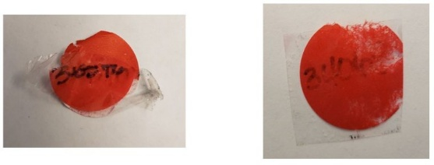

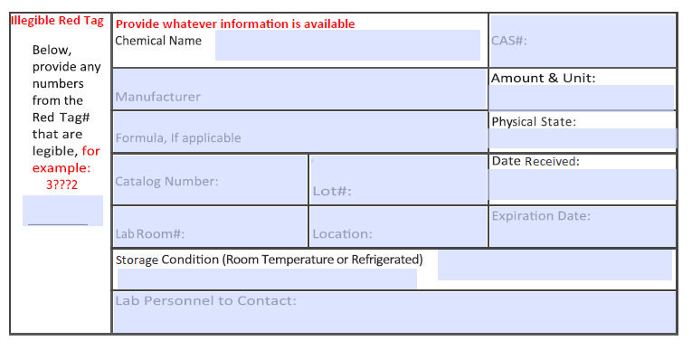

Sample Filled In Form:
