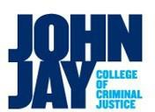 | Fact Sheet  Peroxide---Forming Chemicals

Overview:
Chemicals listed as peroxide---formers have the potential to form explosive crystals under certain circumstances. Stored chemicals that go unused over several months and are exposed to air, heat, moisture, or light can contribute to a potential explosion or injury simply by unscrewing the cap or disturbing the container. It is important to inspect containers for any observable crystals or solids present and to periodically test for non---observable formations of peroxides. CONTACT ENVIRONMENTAL HEALTH AND SAFETY, OR THE SCIENCE LABORATORY DIRECTOR IF PEROXIDES ARE VISIBLE OR IF THERE IS A POSITIVE RESULT WHEN TESTING FOR PEROXIDES.

Instructions:
- Check to see if your laboratory works with any peroxide---forming chemicals. Most chemical manufacturers will indicate, “may form explosive peroxides” on the label.
- Once the peroxide formers are identified, a label must be placed on each container indicating the “Date Received,” “Date Opened,” and “Expiration Date.” This label will be used to determine when to begin testing and when it is time to dispose of the chemical container.
- The allowable time period for use of the chemical may be extended after peroxide testing. This testing is to be completed by laboratory personnel. Peroxide testing strips are available in the Science Department and labels are available through Environmental Health and Safety.
- Contact Environmental Health and Safety for waste peroxides at x4117 or safety@jjay.cuny.edu.
Label for Peroxide Formers Test Strips are available from the Science Department
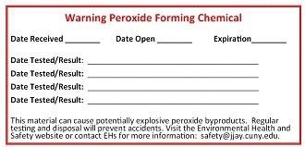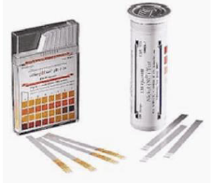
Some Peroxide Forming Chemicals
